**How to check variable’s type:**

* Step 1: Enter Terminal > Type python
* Step 2: type the syntax which is: type(insert types of variables here). 3 types of variables are str, int, and float.

Examples:

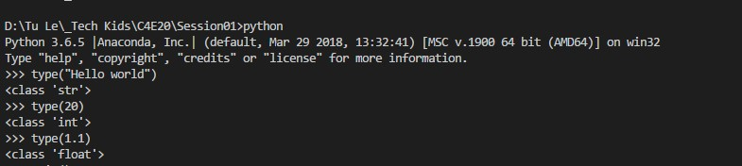

**Case that I get SyntaxError from the compiler telling you that some of my variables have invalid names:**

* Instead of beginning with a letter, my variable starts with a number
* Containing illegal characters like dollar sign: $
* Using Python keywords (30+ forbidden keywords for naming variables). You can check in the tables below:

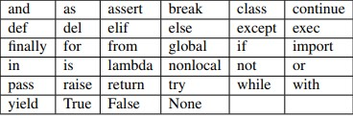

**Here’s 3 examples of invalid names:**

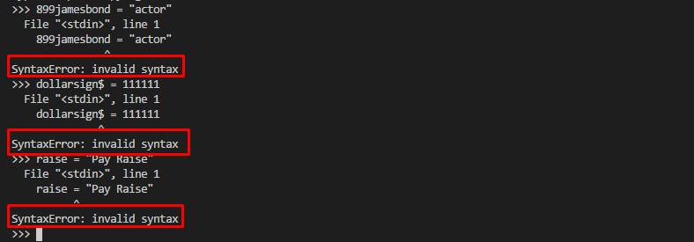

**Signup for Github account:** <https://github.com/tommyle128>